NAME: Sharvayu Zade
PRN: 23070521135
B2 Batch

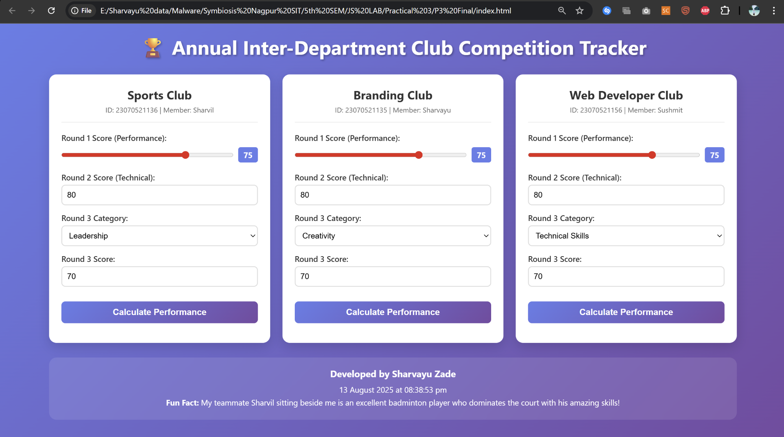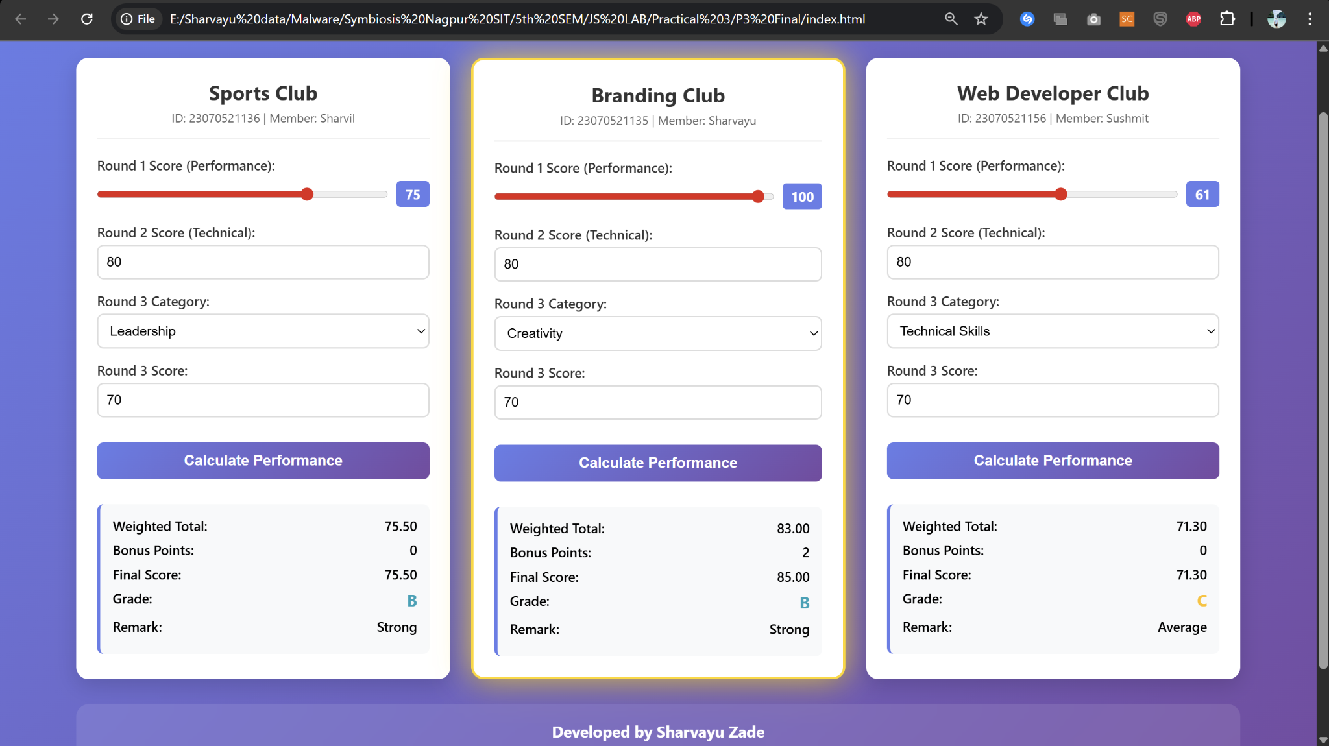
Task: “Campus Club Performance Tracker” Scenario
You are the front-end developer for your batch’s Annual Inter-Department Club Competition. You must create a dynamic performance tracker that records and displays scores for three real club teams from your class.
The tracker must adapt to live inputs.
Rules
1. Team Names & IDs must be real - selected from actual classmates. 2. Criteria Weightings - these values must be typed manually into the JavaScript array. 3. There must be the Bonus Points
4. Tie-breaker condition must be based on the first letter of the team name. 5. Footer must show:
o Your full name
o The date/time
o One fun fact about your real teammate sitting beside you
Requirements
Inputs (for 3 different teams from your batch):
∙ Team Name (text — real club name from your class)
∙ Team ID (number — PRN of any one member)
∙ Round 1 Score (range slider, 0–100)
∙ Round 2 Score (manual number input, 0–100)
∙ Round 3 Category (dropdown generated from a JS array)
Processing Logic:
1. Calculate Weighted Total: Multiply each round score by its weight (Assume suitable weights).
2. Add Bonus Points: e.g., “+5 if Round 2 > 80” or “+3 if category is ‘Innovation’ 3. Assign Grade via if / else if:
o ≥90: A
o 75–89: B
o 60–74: C
o <60: F
4. Assign Remark via switch:
o A → “Outstanding”
o B → “Strong”
o C → “Average”
o F → “Needs Improvement”
5. Highlight the highest scorer’s card (CSS shadow/glow).
6. If tie, apply tie-breaker rule (Assume suitable rule).
Validation:
∙ No score can be below 0 or above 100.
∙ Names must match actual classmates’ club/team names.
∙ Dropdown must randomize order every page load.
Output (on the same page — no alerts):
∙ Team Name & ID
∙ Weighted Total
∙ Grade
∙ Remark
∙ Highlighted Top Card (or tie-breaker winner)
∙ Footer with your name, time, and fun fact about your teammate
Extra Challenge (Mandatory)
∙ Add one custom CSS animation (e.g., card flip, glow) triggered after form submission.
∙ Take a screenshot of the filled, working tracker with real team names & submit along with the code.

